**Mockito exercises**

**Exercise 1: Mocking and Stubbing**

**MyServiceTest1.java**

interface ExternalApi {

String getData();

}

class MyService {

private ExternalApi api;

public MyService(ExternalApi api) {

this.api = api;

}

public String fetchData() {

return api.getData();

}

}

class MockExternalApi implements ExternalApi {

@Override

public String getData() {

return "Mock Data";

}

}

public class MyServiceTest1 {

public static void main(String[] args) {

ExternalApi mockApi = new MockExternalApi();

MyService service = new MyService(mockApi);

String result = service.fetchData();

System.out.println("Expected: Mock Data");

System.out.println("Actual: " + result);

if ("Mock Data".equals(result)) {

System.out.println("✅ Test Passed!");

} else {

System.out.println("❌ Test Failed!");

}

}

}

**Output:**

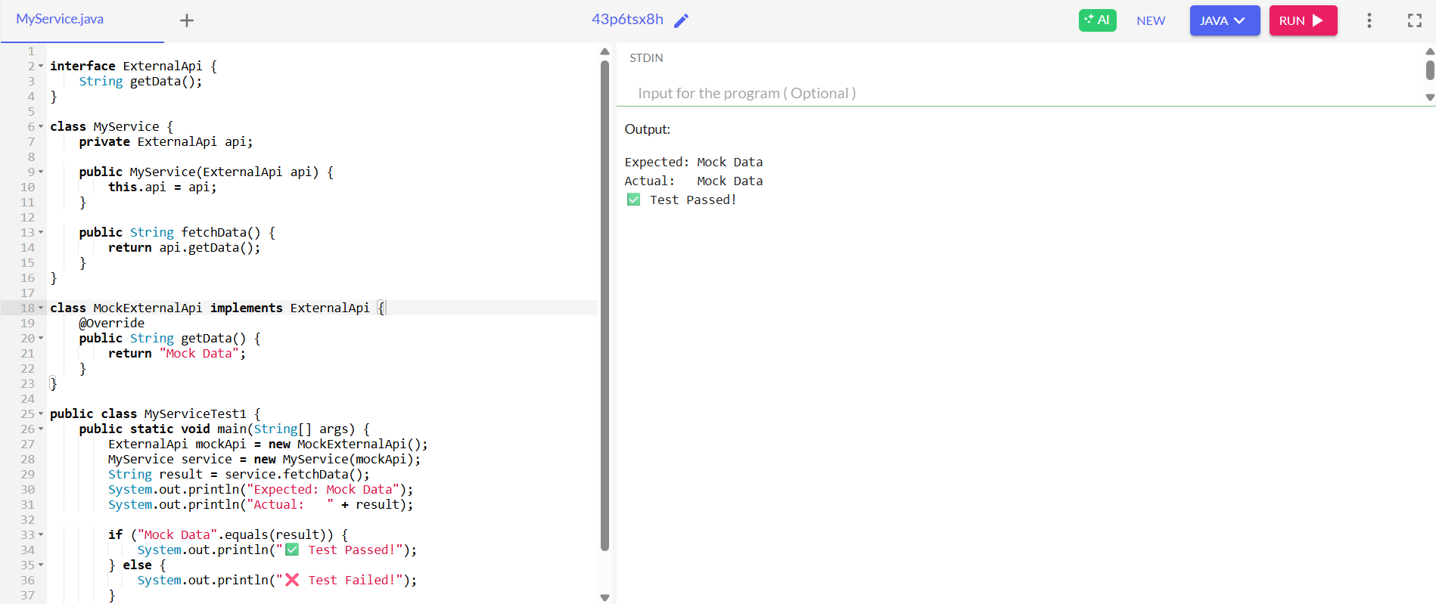

**Exercise 2: Verifying Interactions**

**MyServiceTest2.java**

interface ExternalApi {

String getData();

}

class MyService {

private ExternalApi api;

public MyService(ExternalApi api) {

this.api = api;

}

public String fetchData() {

return api.getData();

}

}

class VerifiableMockApi implements ExternalApi {

boolean wasCalled = false;

@Override

public String getData() {

wasCalled = true;

return "Some Data";

}

public boolean wasGetDataCalled() {

return wasCalled;

}

}

public class MyServiceTest2 {

public static void main(String[] args) {

VerifiableMockApi mockApi = new VerifiableMockApi();

MyService service = new MyService(mockApi);

service.fetchData();

System.out.println("Was getData() called? " + mockApi.wasGetDataCalled());

if (mockApi.wasGetDataCalled()) {

System.out.println("✅ Method interaction verified!");

} else {

System.out.println("❌ Method interaction not verified.");

}

}

}

**Output:**

